This guide is for students, parents and carers. It outlines: Information about the GCSE course; the topics on each examination paper and where students can find revision resources; and ends with examination tips specific to this subject.

Course Title and Exam Board
Exam board | AQA
Course title | Physics
Course structure and assessment | 2 x 1Hour 45 Minute Examinations
Key dates | 22nd May (PM) | Paper one
 | 14th June (AM) | Paper two

GCSE Examinations

Paper | Marks | Duration | Weighting | Topics on this paper
Paper one | 100 | 1hr 45mins | 50% | Topic 1 – Conservation & Dissipation of Energy  Topic 2 – Energy Transfer by Heating  Topic 3 – Energy Resources  Topic 4 – Electric Circuits  Topic 5 – Electricity in the home  Topic 6 – Molecules & Matter  Topic 7 – Radioactivity
Paper two | 100 | 1hr 45mins | 50% | Topic 8 - Forces in Balance  Topic 9 - Motion  Topic 10 - Forces & Motion  Topic 11 - Force & Pressure  Topic 12 - Wave Properties  Topic 13 - Electromagnetic Waves  Topic 14 - Light  Topic 15 - Electromagnetism  Topic 16 - Space

Course Components (a more detailed explanation of skills and topics)

https://filestore.aqa.org.uk/resources/physics/specifications/AQA-8463-SP-2016.PDF

Paper One - Pages 16 - 42

Paper Two - Pages 43 – 73

Where are the revision resources?

Revision topics | What resources to use (website links, student: drive titles of folders/ documents; books recommended etc.)
Paper 1

http://www.physicsandmathstutor.com/physics-revision/gcse-aqa/
https://www.bbc.com/bitesize/examspecs/zsc9rdm
https://app.senecalearning.com/classroom/course/fe56ca00-05aa-11e8-9a61-01927559cfd5

Topic 1 – Conservation & Dissipation of Energy | P Drive /Students/ Science/ Triple Physics/ Paper 1/ Quiz and questions/ Year 10 Revision - Topic 1
Topic 2 – Energy Transfer by Heating | P Drive /Students/ Science/ Triple Physics/ Paper 1/ Quiz and questions/ Year 10 Revision - Topic 2
Topic 3 – Energy Resources | P Drive /Students/ Science/ Triple Physics/ Paper 1/ Quiz and questions/ Year 10 Revision - Topic 3
Topic 4 – Electric Circuits | P Drive /Students/ Science/ Triple Physics/ Paper 1/ Quiz and questions/ Year 10 Revision - Topic 4
Topic 5 – Electricity in the home | P Drive /Students/ Science/ Triple Physics/ Paper 1/ Quiz and questions/ Year 10 Revision - Topic 5
Topic 6 – Molecules & Matter | P Drive /Students/ Science/ Triple Physics/ Paper 1/ Quiz and questions/ Year 10 Revision - Topic 6
Topic 7 – Radioactivity | P Drive /Students/ Science/ Triple Physics/ Paper 1/ Quiz and questions/ Year 10 Revision - Topic 7
Paper 2

http://www.physicsandmathstutor.com/physics-revision/gcse-aqa/
https://www.bbc.com/bitesize/examspecs/zsc9rdm
https://app.senecalearning.com/classroom/course/fe56ca00-05aa-11e8-9a61-01927559cfd5

Topic 8 - Forces in Balance | P Drive /Students/ Science/ Triple Physics/ Paper 2/ Quiz and questions/ Topic 8 - Forces in Balance
Topic 9 - Motion | P Drive /Students/ Science/ Triple Physics/ Paper 2/ Quiz and questions/ Topic 9 - Motion
Topic 10 - Forces & Motion | P Drive /Students/ Science/ Triple Physics/ Paper 2/ Quiz and questions/ Topic 10 - Forces & Motion
Topic 11 - Force & Pressure | P Drive /Students/ Science/ Triple Physics/ Paper 2/ Quiz and questions/ Topic 11 - Force & Pressure
Topic 12 - Wave Properties | P Drive /Students/ Science/ Triple Physics/ Paper 2/ Quiz and questions/ Topic 12 - Wave Properties
Topic 13 - Electromagnetic Waves | P Drive /Students/ Science/ Triple Physics/ Paper 2/ Quiz and questions/ Topic 13 - Electromagnetic Waves
Topic 14 - Light | P Drive /Students/ Science/ Triple Physics/ Paper 2/ Quiz and questions/ Topic 14 - Light
Topic 15 - Electromagnetism | P Drive /Students/ Science/ Triple Physics/ Paper 2/ Quiz and questions/ Topic 15 - Electromagnetism
Topic 16 - Space | P Drive /Students/ Science/ Triple Physics/ Paper 2/ Quiz and questions/ Topic 16 - Space

Three Examination Tips Specific to this Subject

These are the equations you are given in both exams
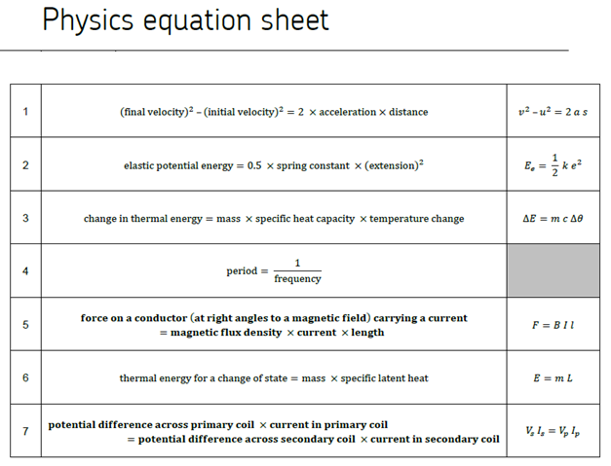

These are the equations you need to learn
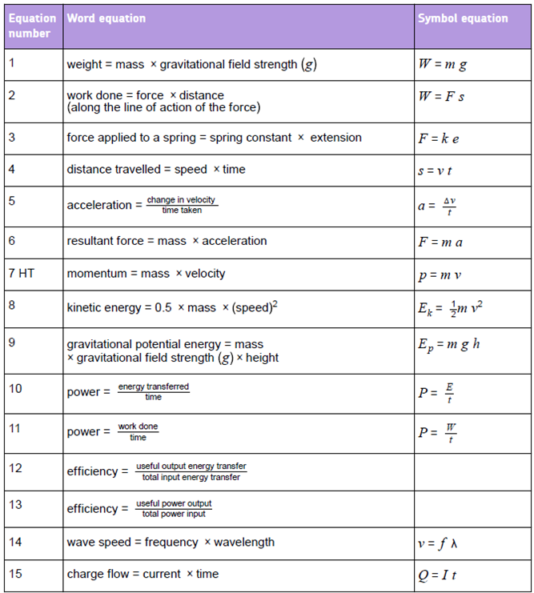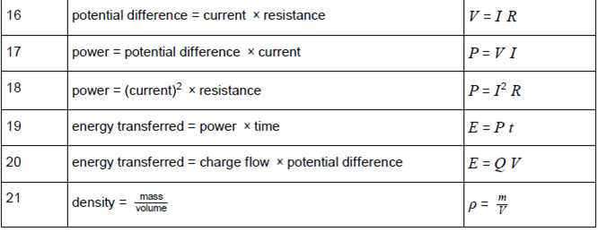

These are the required practicals
Practicals 1-5 are on paper 1
Practicals 6-10 are on paper 2
